**Install Docker Desktop on your Personal laptop:**

<https://docs.docker.com/desktop/install/windows-install/>

Once you install docker desktop -> open docker desktop

Enable Kubernetes from setting:

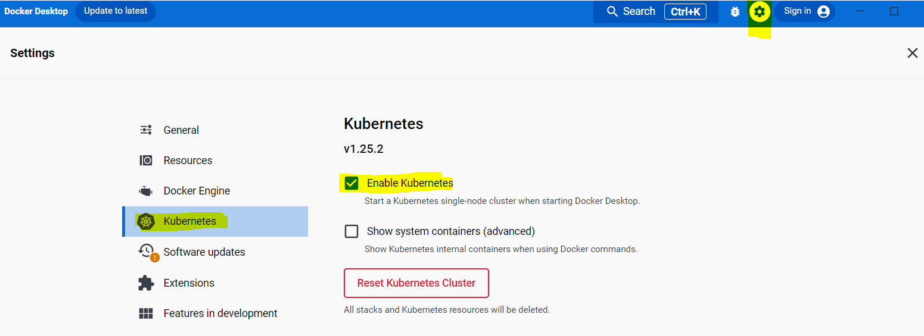

It takes 2-3 minutes to enable Kubernetes. Once enabled successfully, open PowerShell or

command prompt as admin and run Kubernetes commands:

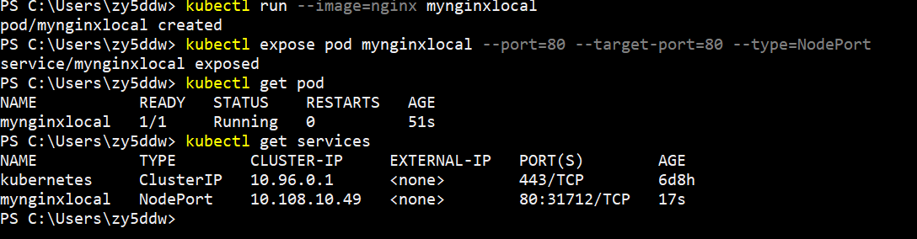

Also you can access deployed Kubernetes Application dashboard from browser

Syntax: http://localhost:<NodePort Port>

Example: in my case NodePort value is 31712

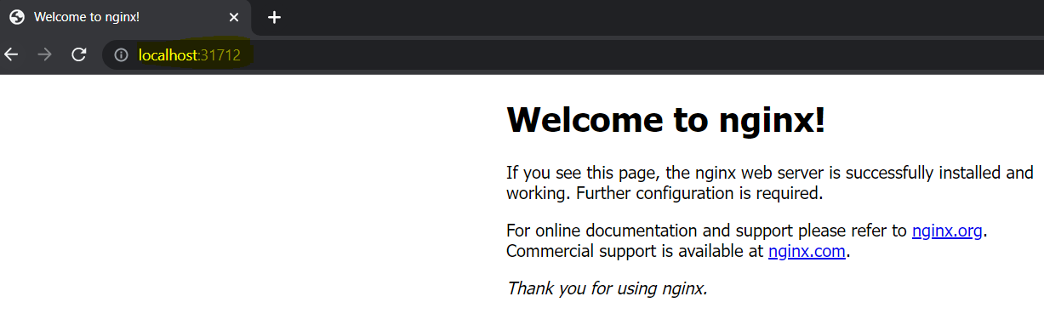

***Note: you won’t be be able to create Service type as LoadBalancer, you can create only NodePort